**IMPROVING VISION IMPAIRED USERS ACCESS TO ELECTRONIC RESOURCES IN E-LEARNING ENVIROMENT**

**BY**

**TYPE YOUR NAME HERE**

**(FPA/CS/19/3-MATRIC NUMBER HERE)**

**SUBMITTED TO**

**THE DEPARTMENT OF COMPUTER SCIENCE**

**SCHOOL SCIENCES AND COMPUTER STUDIES**

**THE FEDERAL POLYTECHNIC, ADO-EKITI, EKITI STATE**

**IN PARTIAL FULFILLMENT OF THE REQUIREMENTS FOR THE AWARD OF HIGHER NATIONAL DIPLOMA (HND)**

**MONTH, 2021**

# CERTIFICATION

I certify that this research project on Improving Vision Impaired Users Access to Electronic Resources in e-Learning Environment is an Original work carried out by YOUR FULL NAME IN UPPERCASE with Registration Number: FPA/CS/18/CS/3-MATRIC has been toughly and duly read under the supervision and guidance of SUPERVISOR’S NAME and found of acceptance by the Department of Computer Science for the award of Higher National Diploma (HND).

NAME OF SUPERVISOR ...........................

*Project Supervisor* *Signature/Date*

NAME OF HOD ...........................

*Head of Department* *Signature/Date*

__________________ ...........................

*External Moderator* *Signature/Date*

# DEDICATION

I dedicate this project work to Almighty God who is the author and finisher of my faith. It is my earnest intention to express my profound gratitude to Almighty God for His enabling grace and to all that have contributed or help in one way or the other to the successful completion of my project.

# ACKNOWLEDGEMENT

I would like to devote an extra gesture of gratitude towards: my supervisor Mr. name of supervisor for a professional academic guidance, My friends for encouraging me with a very useful e-book during my study of machine learning and my project mates for enabling the research and making it possible.

# ABSTRACT

Visual impairment has done a great harm in the life of various individuals having varying eye disabilities ranging from blurred vision, eye sidedness to more serious once such as complete blindness. The majority of academic system has made very little or no provision for such category of individuals. This project will be addressing this problem by converting visual contents into audible information hereby converting the eye requirement of study into a hearing requirement by developing a web application with a text to speech facility. In this study, Python programing language is used to implement an Artificial Neuron algorithm known as Perceptron neuron, hence, converting text into speech. However, this algorithm is not completely hardcoded but made use of two python libraries called python text to speech and speech recognition.

# TABLE OF CONTENTS

CERTIFICATION ii

DEDICATION iii

ACKNOWLEDGEMENT iv

ABSTRACT v

TABLE OF CONTENTS vi

TABLE OF FIGURES viii

CHAPTER ONE 9

INTRODUCTION 9

1.1 Background of the Study 9

1.2 Statement of problem 10

1.3 Aim and Objectives of the Study 11

1.4 Research Methodology 11

1.5 Significance of the study and expected contribution to knowledge 12

1.6 Scope of the Study 12

CHAPTER TWO 13

LITERATURE REVIEW 13

2.1 E-Learning 13

2.2 Vision Impaired Users of e-learning Platforms 16

2.3 Artificial Neural Network and Modelling 16

CHAPTER THREE 19

SYSTEM ANALYSIS AND DESIGN 19

3.1 Application Design and Architecture 19

3.2 User Interface 23

CHAPTER 4 26

SYSTEM DEVELOPMENT AND TESTING 26

4.1 System Development 26

4.2 System Testing 28

REFERENCES 32

APPENDIX 35

# TABLE OF FIGURES

Figure 1.4: Illustration of Machine Learning Process 11

Figure 3.1: Application Design Architecture 19

Figure 3.1.1: Use case Diagram for the application 20

Figure 3.1.2: Entity Relation Diagram 20

Figure 3.1.3-1: Activity Diagram 21

Figure 3.1.3-2: Activity Diagram 22

Figure 3.1.3-3: Speech to text procedure 22

Figure 3.2.1 Login Page 23

Figure 3.2.2: Dashboard 24

Figure 3.3.3: Voice Search Page 24

Figure 3.2.4: Voice to Book Page 25

Figure 3.2.5: Upload Book Page 25

Figure 4.1.1: Word Prediction Methodology 26

Figure 4.2.1: Search Records 29

Figure 4.2.3-1: Word-Text Conversion 29

Figure 4.2.3-2: Voice Records 30

Figure 4.2.3-3: Search Results 30

# CHAPTER ONE

## INTRODUCTION

### Background of the Study

Machine learning is a subset of Artificial Intelligence that allows a computer program to automatically learn from a previous task. It works by analyzing data, identifying patterns, and incorporating minimal human interventions. Almost any work that can be completed with a data-defined pattern or set of rules can be done with machine learning machines. This allows companies to change processes that were previously only possible for people to make assumptions that respond to customer service calls, bookkeeping, and reviews (Prateek Dutta, 2021).

Machine Learning has been further classified into four types. They are categories as follow:

* Supervised Machine Learning
* Unsupervised Machine Learning
* Semi-supervised Machine Learning
* Reinforcement Machine Learning

([Fasola O. O](http://ir.library.ui.edu.ng/browse?type=author&value=FASOLA%2C+O.+O.), 2017) describes Visual impairment as results from diseases, trauma, or a congenital or degenerative condition that cannot be corrected by conventional means. It is a collective term describing an aggregation of various forms and varying degrees of visual handicaps, visual dysfunction and vision loss, which ranges from slight visual and refractive errors, defect in color blindness, partial sightedness, and low vision to blindness. Availability and Access to information materials by persons with visual impairment has received attention of governments, organizations, institutions and individuals who strive to provide library services to them in their environment.

The problem of conversion of information materials into alternative formats is that the process is not only time consuming but also expensive. The consequence of this is that information materials in adjusted format becomes available to the visually impaired several months later (if at all) than to everyone else. A small amount of published works is ever made accessible to the visually impaired. The provision of information materials to persons with visual impairment has remained worrisome to producers and providers of alternative formats. A few materials ever get converted to alternative formats. For instance, only five percent of books published in the United Kingdom (UK) make it into alternative format (Rayini J. 2017). Without alternative formats, persons with visual impairment cannot read and function well as members of the society. This is why it is crucial for every country to have a well-organized arrangement for the production and utilization of information materials by its visually impaired citizens ([Fasola O. O](http://ir.library.ui.edu.ng/browse?type=author&value=FASOLA%2C+O.+O.), 2017).

### Statement of problem

There is that challenge in e-learning of exclusion of vision impaired users as a result of lack of adaptive usability and accessibility to e-learning platforms. Existing e-learning architectures failed to adjust to the calibration parameters of vision impaired users in their design considerations. The existing assistive devices were not designed to adaptively adjust its configurations to suit the requirements of vision impaired users. In order to mitigate this challenge, adaptive and intelligent-based multi-layered feed forward artificial neural network was developed with an adaptive calibrator capable of quantifying imprecise features of vision impaired users

### Aim and Objectives of the Study

The aim of this study is to develop a framework for a reusable intelligent access model to electronic resources for vision impaired users in e-learning environment. In order to achieve this aim, the specific objectives are to:

1. To review what has been done so far relating to this research work.
2. To develop software that will make information accessible to visual impaired users.
3. To convert text into speech using artificial neuron.

### Research Methodology

1. The system will be using UML form structural and behavioral design of the system architecture.
2. Unit and integrated system approaches used to test for the effectiveness of the system
3. The front end was implemented using HTML, CSS, and JAVASCRIPT while the back end was implanted using Python programing language and SQLite database.

The machine learning algorithm learns a set of rules in order to distinguish between two possible classes: default and non-default loan. It then predicts status of a new record without label.



Figure 1.4: Illustration of Machine Learning Process

### Significance of the study and expected contribution to knowledge

This study is significant in providing intelligent access to vision impaired users. The study is envisaged to benefit both the learners and the instructors in e-learning platform. The vision impaired users would be able to learn adaptively at their own pace with reusable and reconfigurable learning contents. Most importantly, the intelligent-based model of the research work provides expert system functionality that keeps track of learners’ achievements and adaptively adjusts to learners’ needs.

### Scope of the Study

The scope of this work is mainly on the vision impaired users of e-learning environment. The work does not address other forms of disabilities that might affect learning. The modified artificial neural network used supervised learning technique for developing dynamic thresholding model.

# CHAPTER TWO

## LITERATURE REVIEW

Several concepts were considered relevant in the course of this work. The list of the concepts included are not exhaustive neither does it reflect the limit of effort in this work. It is however a reflection of value attributed to these concepts of reference.



### E-Learning

The origins of the term e-learning is not certain, although it is suggested that the term most likely originated during the 1980s, within the similar period frame of another delivery mode - online learning. While some authors explicitly defined e-learning, others implied a specific definition or view of e-learning in their article. These definitions materialize, some through conflicting views of other definitions, and some just by simply comparing defining characteristics with other existing terms. In particular, Gentleman, et al., (2017) disagrees with authors like Nichols and Hayasaka (2019) who defined e-learning as strictly being accessible using technological tools that are either web-based, web-distributed, or web-capable. There is a conceptual belief that e-learning not only covers content and instructional methods delivered via CD-ROM, Internet or an Intranet (Benson et al., 2017; Clark, 2017) but also includes audio- and videotape, satellite broadcast and interactive television is the one held by Ellis (2018).

Although technological characteristics are included in the definition of the term, Tavangarian et al. (2018) as well as felt that the technology being used was insufficient as a descriptor. Tavangarian et al. (2018) included the constructivist theoretical model as a framework for their definition by stating that elearning is not only procedural but also shows some transformation of an individual's experience into the individual's knowledge through the knowledge construction process. Ellis (2018) believed that some level of interactivity needs to be included to make the definion truly applicable in describing the learning experience and even though added that eLearning was a type of online learning. As there is still the main struggle as to what technologies should be used so that the term can be referenced, some authors provide either no clear definition or a very vague reference to other terms such as online course/learning, web-based learning, web-based training, learning objects or distance learning, believing that the term can be used synonymously (Dringus and Cohen, 2016; Khan, 2001; Wagner, 2016). What is abundantly obvious is that there is some uncertainty as to what exactly are the characteristics of the term, but what is clear is that all forms of e-learning, whether they be as applications, programs, objects, websites, etc., can eventually provide a learning opportunity for individuals.

Online learning can be difficult to define. Some prefer to distinguish the variance by describing online learning as “wholly” online learning (Oblinger and Oblinger, 2015), whereas others simply reference the technology medium or context with which it is used (Lowenthal et al., 2019). Others display direct relationships between previously described modes and online learning by stating that one uses the technology used in the other (Rekkedal et al., 2017), Online learning is described by most authors as access to learning experiences via the use of some technology (Khan, 2001) identify online learning as a more recent version of distance learning which improves access to educational opportunities for learners described as both non-traditional and disenfranchised. Other authors discuss not only the accessibility of online learning but also its connectivity, flexibility and ability to promote varied interactions (Rekkedal et al., 2017) in particular not only elude to online learning’s' relationship with distance learning and traditional delivery systems but then, like (Rekkedal et al., 2017) makes a clear statement that online learning is a newer version or, and improved version of distance learning. These authors, like many, believe that there is a relationship between distance educations or learning and online learning but appear unsure in their own descriptive narratives.

The process of providing online courses on the Internet for users so that they can study and learn from any place and computing device (personal computer, mobile phone, tablet, etc.) is referred to as e-learning. Even though e-learning has become an increasingly popular training option, it cannot rely just on the upload of contents to the Internet or the developments of new standards. However, it needs to offer a feasible, personalized way that facilitates and enhances the users’ learning process by combining such contents appropriately Ellis (2018). The increasing growth of technology based on internet has led to the emergence of numerous approaches devoted to the field of education reflected in the use of eLearning systems. The rate at which e-learning is being embraced is getting remarkably higher as many institutions have already installed web-based systems for offering online courses. These often complement traditional methods enabling users to engage from any place with their learning through various materials alongside or instead of face-to-face teaching delivery. The European Commission defines the e-learning process as the use of Internet and multimedia technologies to improve the quality of teaching through providing access to resources and educational services as well as enabling remote evaluation, exchange and collaboration between users and lecturers Ellis (2018).

Furthermore, e-learning introduces tremendous benefits to world organizations and stakeholders. Based on the previous literature and research, main advantages of eLearning that highly motivate users in efficiently learning contents include: access flexibility, on-demand availability, personalized instruction, timely content delivery, content standardization, increased convenience, accountability, self-pacing, confidence, and interactivity. Further advantages of e-learning lie behind cost reduction, consistent delivery of learning materials, and enhancement of tracking for universities. Moreover, further research indicated that e-learning systems decrease costs of class-room equipment, training, printed materials, traveling, and labour Ellis (2018).

### Vision Impaired Users of e-learning Platforms

The level of vision-ability of users of e-learning platform has a great impact on the reading rate. It also determines the level of screen magnification suitable for such users. Several low vision aids (LVA) are available to help in enhancing visibility of print text Hayasaka (2019). Another factor influencing level of vision-ability is visual acuity. Visual acuity (VA) is the measurement of the ability to see details.

In order to mitigate the challenge of vision impairment in a print text, the font size of the print text can be increased. The process of increasing the print text size to boost vision is referred to as magnification Hayasaka (2019). Moreover, screen reading assistive devices are used to reduce the limitation of low vision. Some of the software deployed in this regards are Jaws, Microsoft NVDA, G Nopernicus, Window-eye, Supernova, e.t.c. (Clark, 2017).

### Artificial Neural Network and Modelling

Many tasks involving intelligence or pattern recognition are extremely difficult to automate, but appear to be performed very easily by humans. For instance, humans recognize various objects and make sense out of the large amount of visual information in their surroundings, apparently requiring very little effort. It stands to reason that computing systems that attempt similar tasks will profit enormously from understanding how humans perform these tasks, and simulating these processes to the extent allowed by physical limitations. This necessitates the study and simulation of Neural Networks. The neural network of an human is part of its nervous system, containing a large number of interconnected neurons (nerve cells). “Neural” is an adjective for neuron, and “Network” denotes a graph like structure. Artificial Neural Network (ANN) refers to computing systems whose central theme is borrowed from the analogy of biological neural networks. Artificial Neural Networks are also referred to as “Neural Nets”, “parallel distributed processing systems” and “connectionist systems”. For a computing system to be called by these pretty names, it is necessary for the system to have a labeled directed graph structure where nodes perform some simple computations. From elementary graph theory, it is recalled that a “Directed Graph” which consists of a set of “Nodes” (vertices) and a set of “Connections” (edges/links/arcs) connecting pairs of nodes. In a neural network, each node performs some simple computations, and each connection conveys a signal from one node to another, labeled by a number called the “Connection Strength” or “Weight” indicating the extent to which a signal is amplified or diminished by connection. This system is the alternative for human expertise and knowledge. Artificial Neural Networks are modeled closely following the brain and therefore a great deal of terminology is borrowed from neuroscience.

Kurban investigated that an artificial neural network are non-linear mapping systems with a structure loosely based on principles observed in the biological nervous systems. In greatly simplified terms, a typical real neuron has a branching dendritic tree that collects signals from many other neurons in a limited area; a cell body that integrates collected signals and generates a response signal (as well as manages metabolic functions); and along branching axon that distributes the response through contacts with dendritic trees of many other neurons. The response of each neuron is a relatively simple non-linear function of its inputs and is largely determined by the strengths of the connections from its inputs. In spite of the relative simplicity of the individual units, systems containing many neurons can generate complex and intersecting behaviors (Clark, 2017).

In general terms, a NN consists of large number of simple processors linked by weighted connections. By analogy, the processing nodes may be called “neurons”. Each node output depends only on the information that is locally available at the node, either stored internally or arriving via the weighted connections. Each unit receives inputs from many other nodes and transmits its output to other nodes. By itself, a single processing element is not very powerful; it generates a scalar output with a single numerical value, which is a simple non-linear function of its inputs. The power of the system emerges from the combination of many units in an appropriate way. A network is utilized different function by varying the connection topology and the values of the connecting weights. Complex functions can be implemented by connecting the units together with appropriate weights. It has been shown that a sufficiently large network with an appropriate structure and property chosen weights can approximate with arbitrary accuracy any function satisfying certain broad constraints Gentleman, et al., (2017). This model is a drastically simplified approximation of real nervous systems. The intent is to capture the major characteristics important in the information processing functions of real networks without varying too much about the physical constraints imposed by biology. Artificial NN are made up of simple, highly interconnected processing units called neurons, each of which performs two functions, namely, aggregation of its inputs from other neurons or the external environment and generation of an output from the aggregated inputs. Through this simple structure, neural networks have been shown to be able to approximate most continuous functions to any degree of accuracy, by choice of an appropriate number of neuron units Gentleman, et al., (2017).

# CHAPTER THREE

## SYSTEM ANALYSIS AND DESIGN



### Application Design and Architecture

Figure 1.4 shows an overview of the architecture of the application. The user opens the app on a web browser. To start using the app as well as have access to the data the user needs to first login to the system using his/her credentials as proper credentials are needed for authentication purpose. The user on his/her part enters the required information (in form of text or voice message) into the system, the system converts voice message into text and text into voice where needed using machine learning modules.

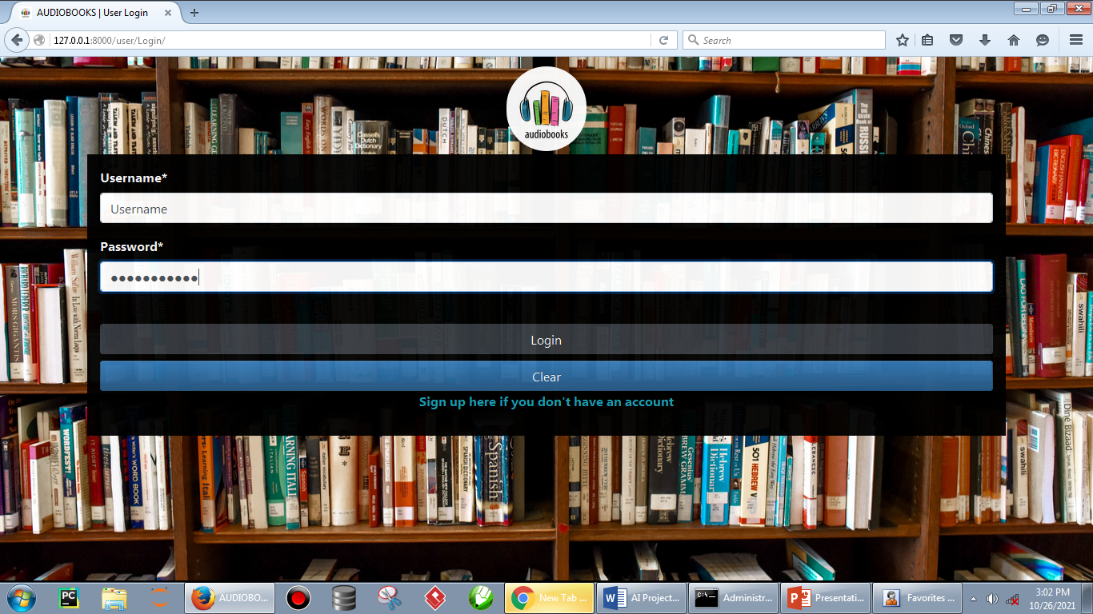

Figure 3.1: Application Design Architecture

The application is web based rendered using SQLite Server. The user needs to have an internet connection to have access to the data on the database, also it is required to make any necessary changes. Figure 3-1 is a reference image which shows the basic architecture of the application.

#### Use case diagram

The use case diagram (Figure 3.1.1.) demonstrates the sequence of operations that user will be able to perform with different modules of the application along with the associations. The user able to interact with the application after a successful login. The search for book either by text or voice note, record voice note which can be converted into text for others to read, upload e-books which can be converted into audio for listening, and also keep track of previous search records.

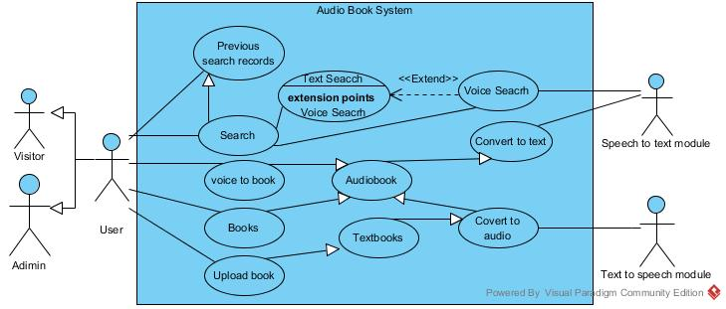

Figure 3.1.1: Use case Diagram for the application

#### Entity relation diagram

The entity relation diagram shows graphically represents the tables in the database as well as their relationships. The database consists of four tables which are interrelated. The User Table which stores the user information such as username and password among others, the Book Table which keep records of text e-books uploaded by users, the Search Table that keeps track of previous searches by users and the Record Table that keeps track of the voice records that are to be converted into text.

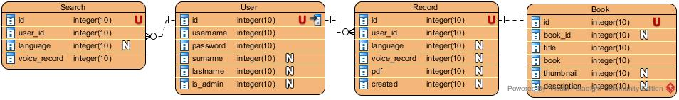

Figure 3.1.2: Entity Relation Diagram

#### Activity diagram

The use of Activity Diagrams visually presents a series of actions or flow of control in the system. The series of actions taking place to convert speech to text as well as text to speech. The figure 3.1.3-1 shows the various steps for recording a voice, saving it as audio and converting it into a text e-book.

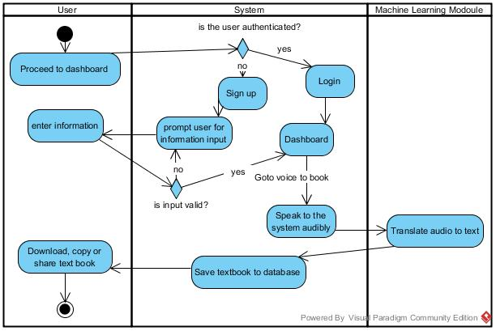

Figure 3.1.3-1: Activity Diagram

The figure 3.1.3-2 illustarates the series of actions taking place in the process of conducting a voice seacrch. It can be seen from figures 3.1.3-1 and 3.1.3-2 that both operationsrequires that the user is properly logged in (authenticated).

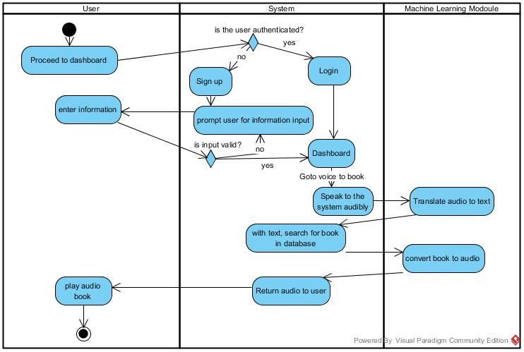

Figure 3.1.3-2: Activity Diagram

Figure 3.1.3-3 clearly shows the steps taken by user to convert voice note into a text book. After logged in successful, the user clicks voice to book in the dashboard, clicks on the micro phone on the speech to text page, clicks on the record button and click on it again to stop recording after delivering speech, then submits.

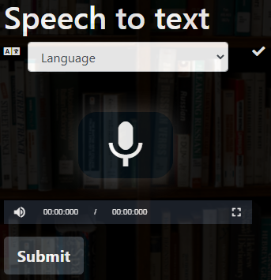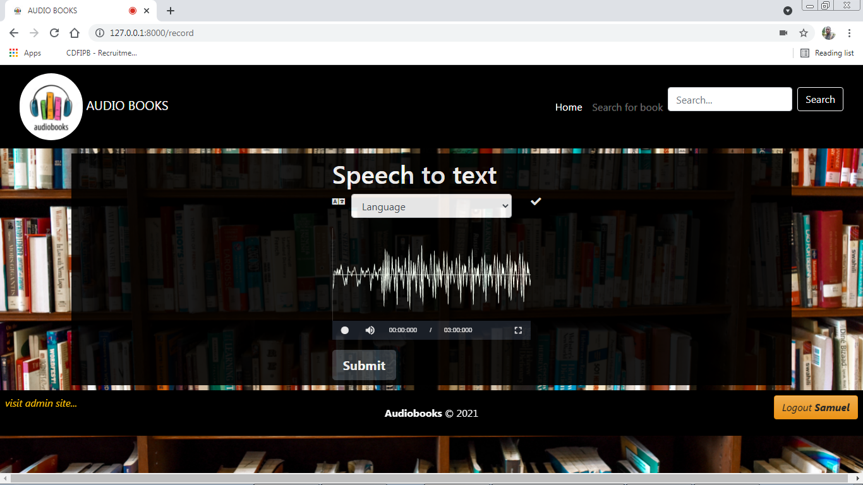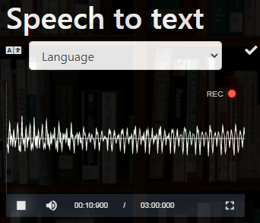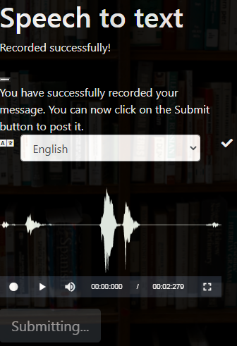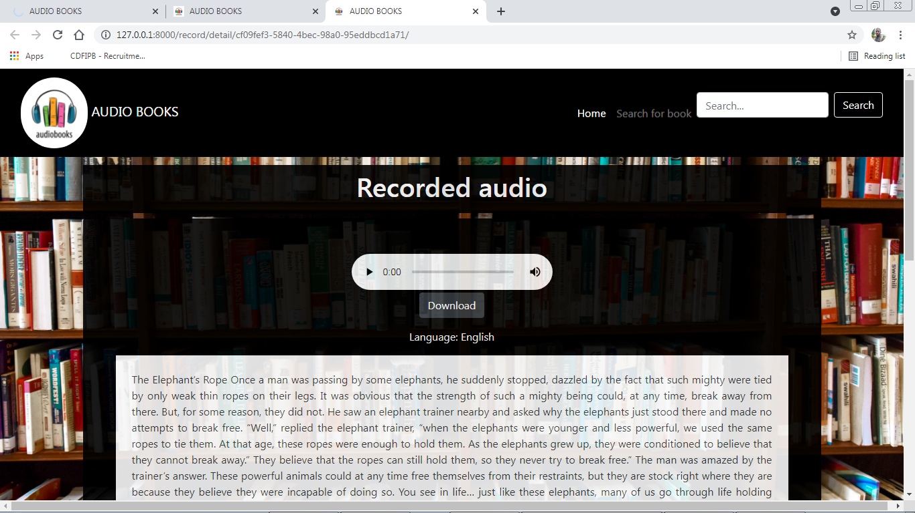

Figure 3.1.3-3: Speech to text procedure

### User Interface

This section describes the user interface design of the loan prediction and recommendation system.

#### Login

Figure 3-5 shows the screen which is shown when the app opens. It is the login screen in which the user needs to give in his credentials to login to the app.

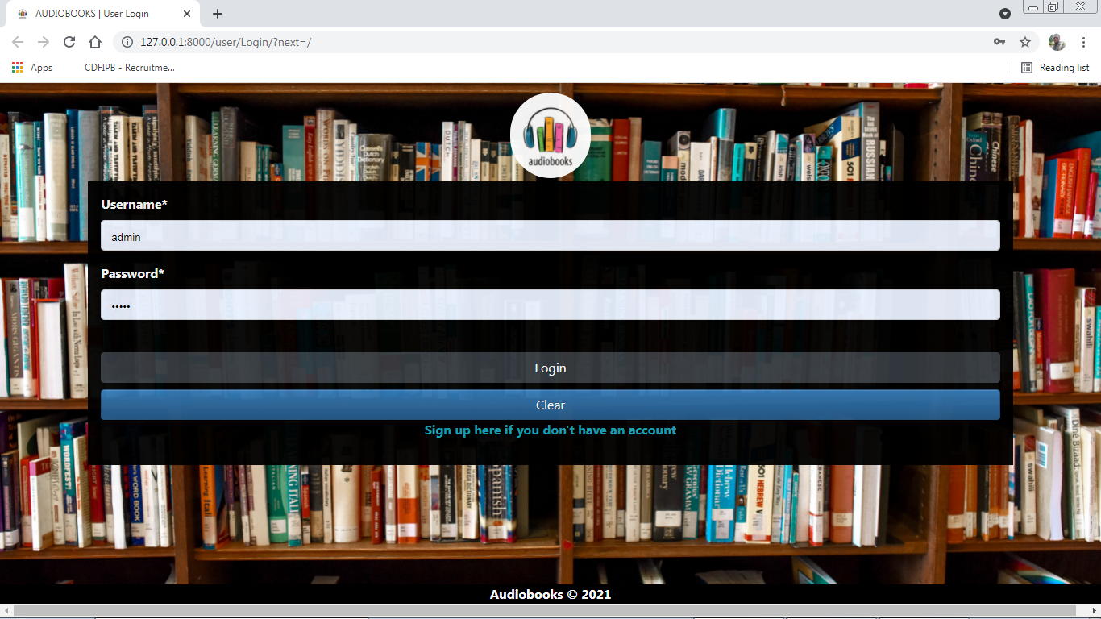

Figure 3.2.1 Login Page

#### Dashboard

Upon successful login, the dashboard of the application is displayed where there are a number of tools available to the user. Dashboard is shown in the Figure. 3.2.2 below.

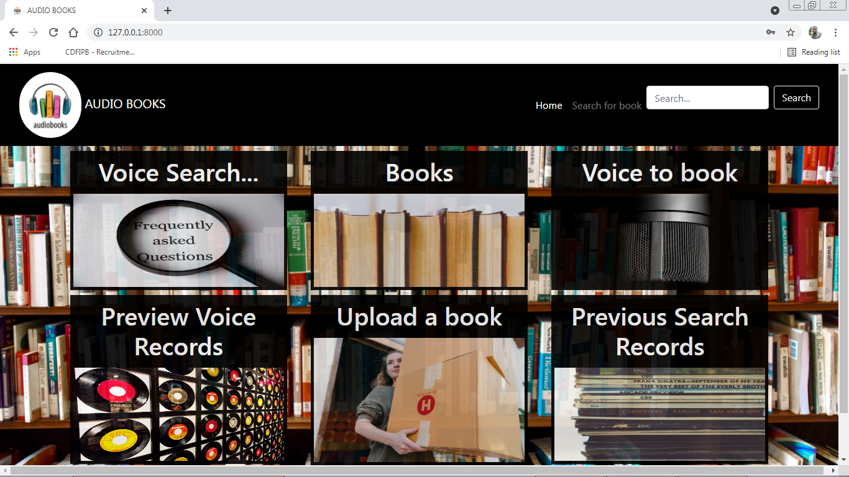

Figure 3.2.2: Dashboard

#### Voice search page

The user clicks the microphone button at the center of the page, clicks the start button and speak words to be searched, clicks submit and the search results are returned by the system.

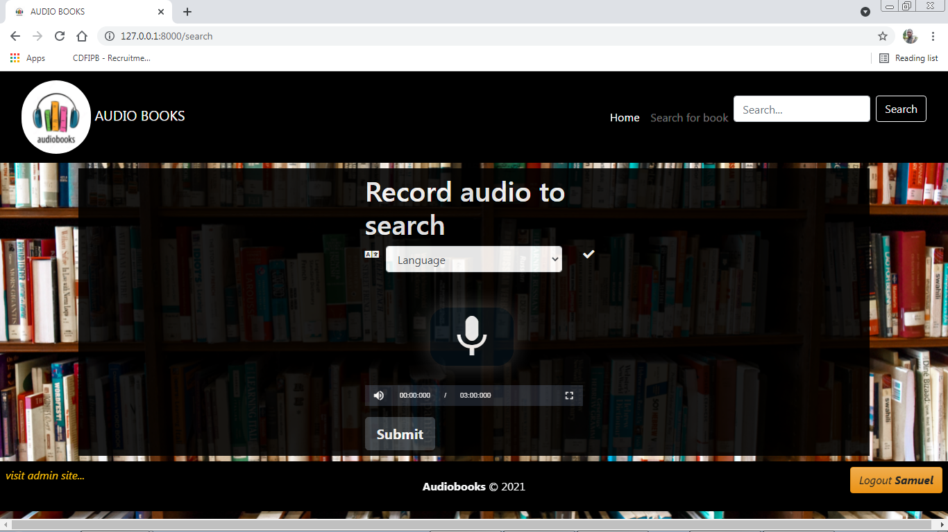

Figure 3.3.3: Voice Search Page

#### Voice to book page

This page enables the user to say words that will be automatically typed by the system. The system returns the text equivalent information.

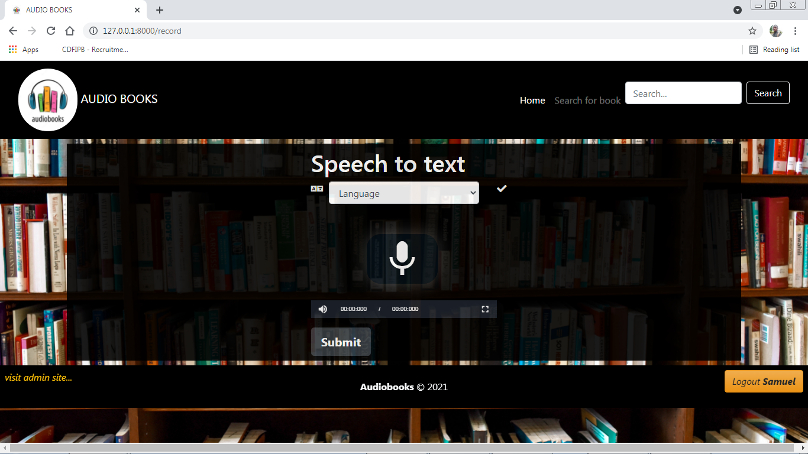

Figure 3.2.4: Voice to Book Page

#### Upload book page

The user fills the form correctly and submits the form. The system validates the information and passes it to the database. These uploaded books can then be accessed by other users either as text or audio formats.

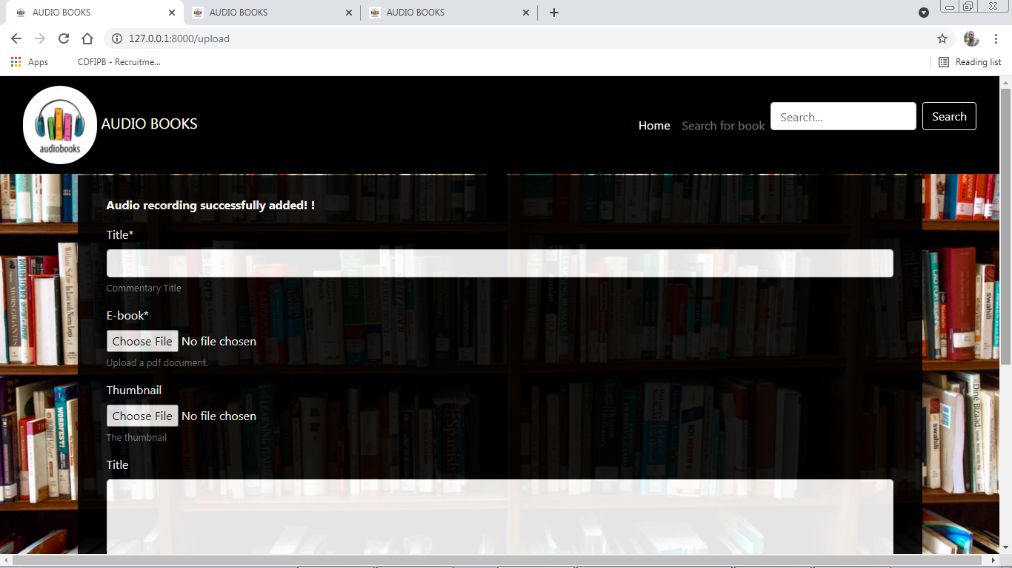

Figure 3.2.5: Upload Book Page

# CHAPTER 4

## SYSTEM DEVELOPMENT AND TESTING



### System Development

#### Word prediction methodology

The following diagram represents the procedure for prediction in supervised machine learning techniques.



Figure 4.1.1: Word Prediction Methodology

The training dataset consists of several thousands of records, a higher portion of the records are meant for training our model while the rest are meant for testing our model.

#### Collection of voice

Collection of voice is done using JavaScript JQuery libraries and submitted to the server for further processing. This is illustrated by the code snippet bellow.

function RecordRTC(mediaStream, config) {

if (!mediaStream) {

throw "First parameter is required.";

}

config = config || {

type: "video",

};

config = new RecordRTCConfiguration(mediaStream, config);

// a reference to user's recordRTC object

var self = this;

function startRecording(config2) {

if (!config.disableLogs) {

console.log("RecordRTC version: ", self.version);

}

if (!!config2) {

// allow users to set options using startRecording method

// config2 is similar to main "config" object (second parameter over RecordRTC constructor)

config = new RecordRTCConfiguration(mediaStream, config2);

}

if (!config.disableLogs) {

console.log("started recording " + config.type + " stream.");

}

if (mediaRecorder) {

mediaRecorder.clearRecordedData();

mediaRecorder.record()

#### Speech to text

The voice message is converted into text using python Speech Recognition module.. This module consists of several machine learning trained models. This is shown below in the code snippet.

def speech_txt(voice_note, language):

    r = sr.Recognizer()

    voice_note = "." + voice_note

    ffmpeg_tools.ffmpeg_extract_audio(voice_note, 'note.wav')

    sound = './note.wav'

    with sr.AudioFile(sound) as source:

        audio = r.listen(source)

        try:

            my_text = r.recognize_google(audio, language=language)

            results = { 'my_text': my_text, 'status':'success'}

        except Exception as e:

            results = { 'status': 'unsuccessful', 'e':e }

        return results

#### Text to speech

This is achieved by integrating the python pyttsx3 (Python Text To Speech Extension 3). This is also illustrated by the bellow code snippet.

def book_reader(id):

book = Book.objects.get(id=id)

file_dir = '.'+book.book.url

text=''

try:

pdfReader = PyPDF2.PdfFileReader(open(file_dir, 'rb'))

for page_num in range(pdfReader.numPages):

text2 = pdfReader.getPage(page_num).extractText()

text = text+ '' + text2

engine = pyttsx3.init()

engine.save_to_file(text, 'static/audio.mp3')

engine.runAndWait()

engine.stop()

#myaudio = gTTS(text=text, lang='en')

#myaudio.save('audio.mp3')

results = {

'status':'success'

}

except Exception as e:

results = {

'status': 'unsuccessful',

'e':e

}

return results

### System Testing

#### Machine learning models:

After testing our already trained machine learning models with random words and statement. The models performed well and predicted the right words. Below is shown an example of the search records in figure 4.2.1.

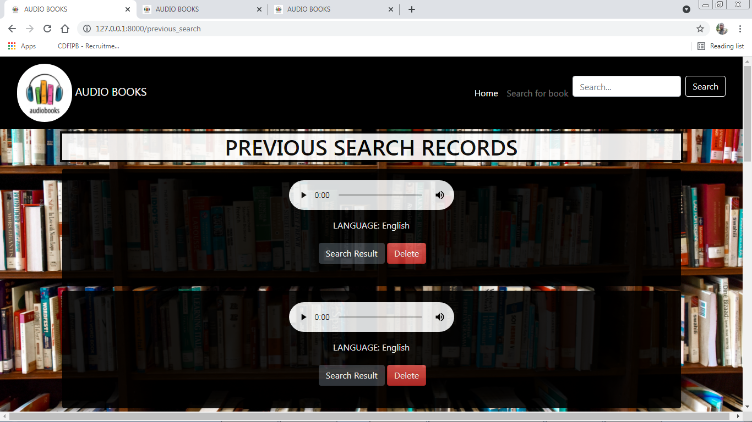

Figure 4.2.1: Search Records

#### Login:

This test case checked the smooth login process of the application. The application accepted the user password with username and redirected to the homepage quickly

#### Word-Audio processing:

Text to speech as well as speech to text was tested and worked perfectly. This is shown in the figure 4.2.3-1.

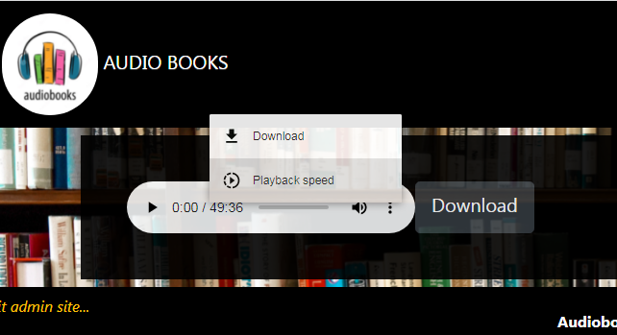

Figure 4.2.3-1: Word-Text Conversion

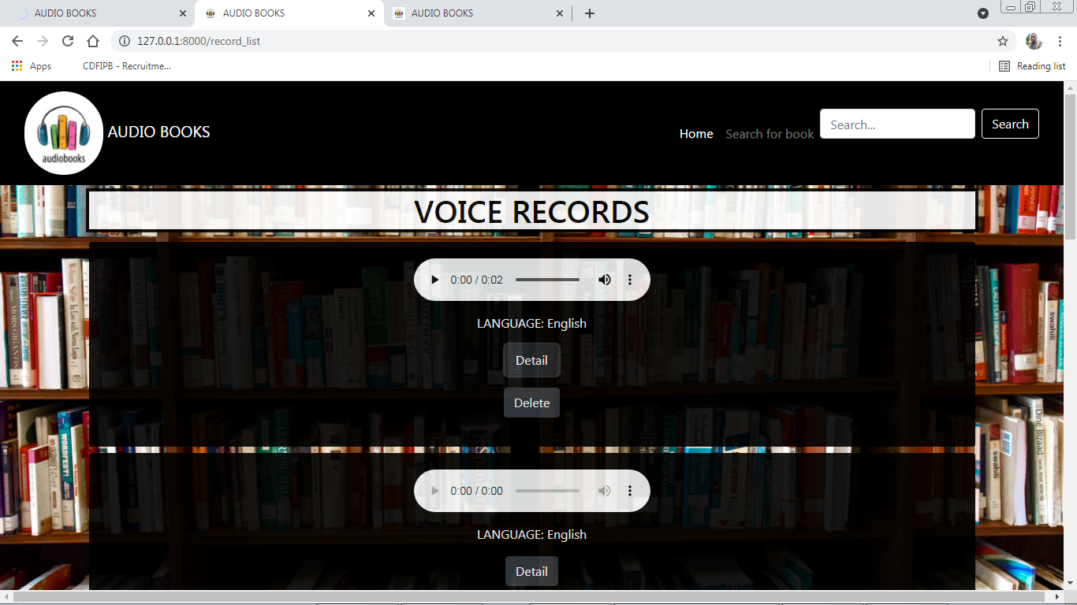

Figure 4.2.3-2: Voice Records

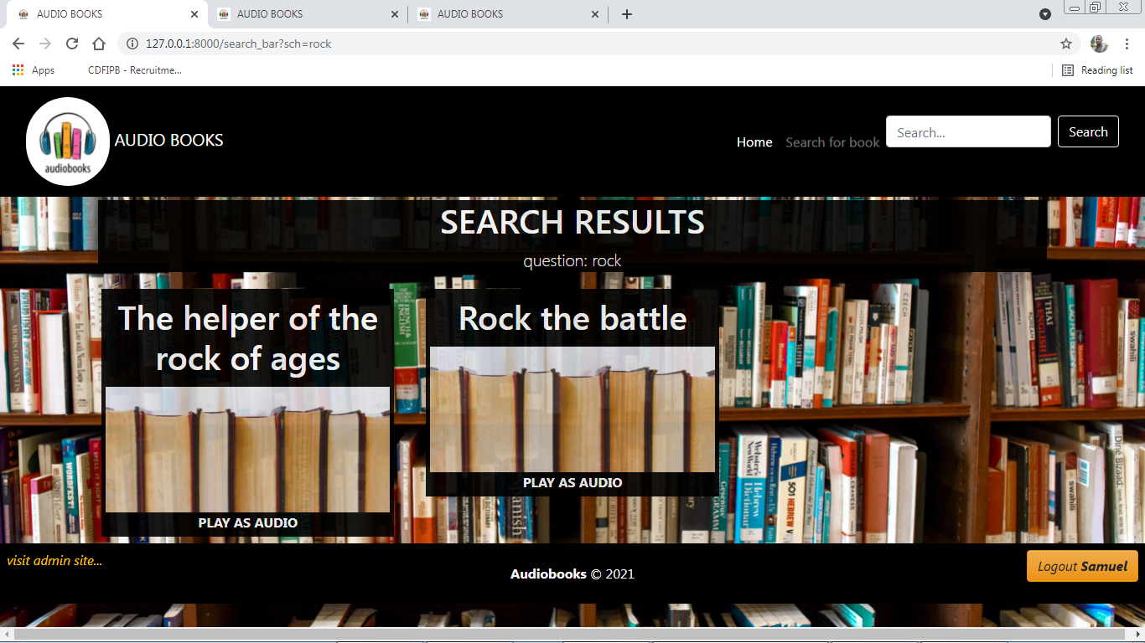

Figure 4.2.3-3: Search Results

#### User Feedback:

Several users were contacted to receive feedback, on the usability of the application. The users liked the outlook of the application, also they opinioned that it is user friendly and that it would be very helpful to visually impaired individuals.

# REFERENCES

Benson, P. & Reinders, H., (2017). Research agenda: Language learning beyond the classroom. *Language Teaching*, *50*(4), 561-578.

Clark, D., Del Gaizo, J., Mofrad, N., Jensen, J. H., Glenn, R., Helpern, J., & Bonilha, L. (2017). Using machine learning to classify temporal lobe epilepsy based on diffusion MRI. *Brain and behavior*, *7*(10), e00801.

Dringus, L. P., & Cohen, M. S. (2016, October). An adaptable usability heuristic checklist for online courses. In *Proceedings Frontiers in Education 35th Annual Conference* (pp. T2H-6). IEEE.

Ellis, K., Mansbridge, N., Mitsch, J., Bollard, N., Miguel-Pacheco, G. G., Dottorini, T., & Kaler, J. (2018). Feature selection and comparison of machine learning algorithms in classification of grazing and rumination behaviour in sheep. *Sensors*, *18*(10), 3532.

[Fasola, O. O.](http://ir.library.ui.edu.ng/browse?type=author&value=FASOLA%2C+O.+O.) 2017. “Improving Vision Impaired Users Access to Electronic Resources in E-Learning Environment with Modified Artificial Neural Network,” University of Ibadan Instututional Repository. <http://ir.library.ui.edu.ng/handle/123456789/4032>

Gentleman, M., Smith, S., Loads, D., & Pullin, S. (2017). An exploration of a restorative space: A creative approach to reflection for nurse lecturers focused on experiences of compassion in the workplace. *Nurse Education Today*, *34*(9), 1225-1231.

Hayasaka, T., Lin, A., Copa, V. C., Lopez, L. P., Loberternos, R. A., Ballesteros, L. I. M., ... & Lin, L. (2020). An electronic nose using a single graphene FET and machine learning for water, methanol, and ethanol. *Microsystems & Nanoengineering*, *6*(1), 1-13.

Hersh MA, García Ramírez AR. 2018 “Evaluation of the electronic long cane: improving mobility in urban Areas”

Khan, B. H. (2016). A framework for web-based learning. *Web-based training*, 75-98.

Oblinger, D., Oblinger, J. L., & Lippincott, J. K. (2015). *Educating the net generation*. Boulder, Colo.: EDUCAUSE, c2005. 1 v.(various pagings): illustrations..

Prateek Dutta. 2021. “A Study on Machine Learning Algorithm for Enhancement of Prediction.” International Research Journal Engineering Technology and of Modernization in Science. Volume: 03/Issue: 01/January-2021. [www.irjmets.com](http://www.irjmets.com). e-JSSN: 2582-5208.

Rayini J. 2017 “Suggestive Guidelines for Improving Library and Information Services to The Visually Impaired” Library Philosophy and Practice (e-journal).

Rekkedal, T., Qvist-Eriksen, S., Keegan, D., Súilleabháin, G. Ó., Coughlan, R., & Fritsch, H. (2017). Internet based e-learning, pedagogy and support systems. *Norway: NKI Distance Education*.

Rodrigo-Salazar L, [Gonzalez-Carrasco](https://scholar.google.com/citations?user=iYoS6zcAAAAJ&hl=en&oi=sra) I. 2021 – “[An IoT-based contribution to improve mobility of the visually impaired in Smart Cities](https://link.springer.com/article/10.1007/s00607-021-00947-5)”

Sample, M., Boulicault, M., Allen, C., Bashir, R., Hyun, I., Levis, M., & Zartman, J. (2019). Multi-cellular engineered living systems: building a community around responsible research on emergence. *Biofabrication*, *11*(4), 043001.

Sankalpani P, Wijesinghe I, Jeewan I – 2018. [“Smart Assistant: A solution to facilitate vision impaired individuals](https://ieeexplore.ieee.org/abstract/document/8550059/)” ieeexplore.ieee.orgi

Tavangarian, D. (2018). Is e‑Learning the Solution for Individual Learning?. *Electronic Journal of E-learning*, *2*(2), pp265-272.

Wagner, C., Bluhm, C. & Overbeck, L. (2016). *Introduction to credit risk modeling*. Crc Press.

# APPENDIX

from django.shortcuts import render, redirect

from django.contrib import messages

from django.http.response import JsonResponse

from django.shortcuts import get_object_or_404, render

from .models import Record, Book, Search

from .converter import speech_txt, book_reader

from django.db.models import Q

from django.core.paginator import Paginator

from django.contrib.auth.decorators import login_required

from .forms import BookForm

from django.core.files import File

import os

@login_required(login_url='veriuser:login')

def index(request):

return render(request, 'home.html', {

})

@login_required(login_url='veriuser:login')

def books(request):

return render(request, 'books.html', {

'books': Book.objects.all(),

})

@login_required(login_url='veriuser:login')

def add_book(request):

context = {}

if request.method == 'POST':

form = BookForm(request.POST, request.FILES)

if form.is_valid():

form.save()

messages.success(request, 'Book successfully added')

return redirect('library:add_book')

else:

context['form'] = form

context['error'] ='invalid input'

return render(request, "add_book.html", context)

else:

form = BookForm()

context['form'] = form

return render(request, "add_book.html", context)

@login_required(login_url='veriuser:login')

def delete_record(request,id):

_record= get_object_or_404(Record,id=id)

_record.delete()

return redirect('library:record_list')

@login_required(login_url='veriuser:login')

def play_book(request,id):

results = book_reader(id)

if results['status'] == 'success':

return render(request, 'book_reader.html', {})

else:

e = results['e']

#return redirect('library:error',e)

context={'e':results['e']}

return render(request, "error.html", context)

@login_required(login_url='veriuser:login')

def record(request):

if request.method == "POST":

language = request.POST.get("language")

audio_file = request.FILES.get("recorded_audio")

_record = Record(language=language, voice_record=audio_file, user=request.user)

_record.save()

results = speech_txt(_record.voice_record.url,language)

if results['status'] == 'success':

_record = Record(language=language, voice_record=audio_file, user=request.user, pdf=results['my_text'])

_record.save()

else:

return redirect('library:error', results['e'])

messages.success(request, "Audio recording successfully added!")

return JsonResponse(

{

"url": _record.get_absolute_url(),

"success": True,

}

)

context = {"page_title": "Record audio"}

return render(request, "record.html", context)

@login_required(login_url='veriuser:login')

def record_detail(request, id):

_record = get_object_or_404(Record, id=id)

context = {

"page_title": "Recorded audio detail",

"record": _record,

}

return render(request, 'record_detail.html', context)

#return FileResponse(open('f.pdf', 'rb'), as_attachment=True, content_type='application/pdf')

@login_required(login_url='veriuser:login')

def record_list(request):

context = {}

records = Record.objects.filter(user=request.user)

if records.count() == 0:

context['empty'] = 'You have no previous voice records '

return render(request, 'record_list.html', context)

else:

paginator = Paginator(records, 10)

page = request.GET.get('page')

results = paginator.get_page(page)

context['results'] = results

return render(request, 'record_list.html', context)

@login_required(login_url='veriuser:login')

def previous_search(request):

context = {}

searches = Search.objects.filter(user=request.user)

if searches.count() == 0:

context['empty'] = 'You have no previous search records '

return render(request, 'previous_search.html', context)

else:

paginator = Paginator(searches, 9)

page = request.GET.get('page')

results = paginator.get_page(page)

context['results'] = results

return render(request, 'previous_search.html', context)

@login_required(login_url='veriuser:login')

def search(request):

context = {}

if request.method == "POST":

audio_file = request.FILES.get("recorded_audio")

language = request.POST.get("language")

_search = Search(voice_record=audio_file, user=request.user, language=language)

_search.save()

messages.success(request, "Audio recording successfully added!")

return JsonResponse(

{

"url": _search.get_results_url(),

"success": True,

}

)

context = {"page_title": "Record audio"}#don't touch

return render(request, "search.html", context)

@login_required(login_url='veriuser:login')

def search_result(request, id):

context = {}

_search = get_object_or_404(Search, id=id)

voice_note = _search.voice_record.url

language = _search.language

results = speech_txt(voice_note, language)

if results['status'] == 'success':

my_text = results['my_text']

queryset = (Q(title__icontains=my_text) | Q(description__icontains=my_text))

results = Book.objects.filter(queryset).distinct()

if results.count() == 0:

context['question'] = my_text

context['no_result'] = 'no results found for this search: '+my_text

return render(request, 'search_results.html', context)

else:

paginator = Paginator(results, 9)

page = request.GET.get('page')

results = paginator.get_page(page)

context['question'] = my_text

context['results'] = results

return render(request, 'search_results.html', context)

else:

return redirect('library:error', results['e'])

@login_required(login_url='veriuser:login')

def search_detail(request, id):

record = get_object_or_404(Record, id=id)

context = {

"page_title": "Recorded audio detail",

"record": record,

}

return render(request, "record_detail.html", context)

@login_required(login_url='veriuser:login')

def delete_search(request,id):

_search = get_object_or_404(Search, id=id)

_search.delete()

return redirect('library:previous_search')

@login_required(login_url='veriuser:login')

def error(request, e):

context = {'e':e}

return render(request, "error.html", context)

@login_required(login_url='veriuser:login')

def search_bar(request):

context = {}

my_text = request.GET.get('sch', '')

queryset = (Q(title__icontains=my_text) | Q(description__icontains=my_text))

results = Book.objects.filter(queryset).distinct()

if results.count() == 0:

context['question'] = my_text

context['no_result'] = 'no results found for this search: '+my_text

else:

paginator = Paginator(results, 9)

page = request.GET.get('page')

results = paginator.get_page(page)

context['question'] = my_text

context['results'] = results

return render(request, 'search_results.html', context)